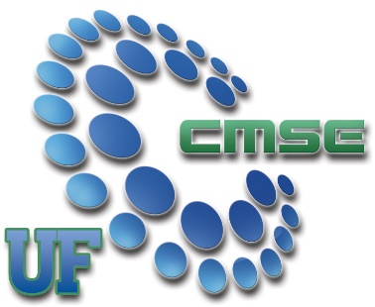**Center for Macromolecular Science and Engineering**

[**http://www.cmse.ufl.edu/**](http://www.cmse.ufl.edu/)

**OUR VISION:** The Center for Macromolecular Science and Engineering promotes interdisciplinary collaboration in our polymer science and engineering program at the University of Florida and serves as a conduit between industry, government and UF. We stress a fundamental approach in our research while seeking solutions to practical problems. We pursue excellence in all our endeavors. Our conduct is characterized by ethics, integrity, and honesty.

**Director of Information Technology, Gainesville, FL***part time, 15 hours per week, $XX / hour*

The Center for Macromolecular Science and Engineering at the University of Florida is seeking a long-term, passionate, self-directed student to fill the upcoming vacancy in the role of Director of Information Technology. The position requires hours per week relative to the workload. Scheduling is generally flexible. The student will be able to work remotely on specific website maintenance tasks. The student is suggested to be present in the Polymer office in Leigh hall a few times per week.

Responsibilities Include:

* Management of 2 chemistry department websites (CMSE, BPRL)
* Management of 1 group website (Sumerlin)
* Management of 1 Facebook page (CMSE)
* Management of digital archives (CMSE)
* Communicate with professors, students, and student groups to procure content for websites
* Create various publications and posters in support of departmental objectives
* Assist in technology-based office projects, including development of new websites, communication mediums, and technology infrastructure
* Assist in miscellaneous office tasks

Successful candidates will be:

* Self-starter
* Self-directed
* Great communication skills
* Display professional communication etiquette
* Reliable

**How to Apply**

[placeholder text, need to have an online application process!]